Agentic AI Coding Assistants

Repeatable workflow
Created two STTM Document Customer and TPM Promotion document.
Prompt Created
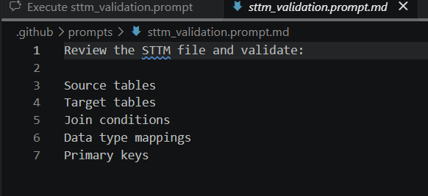
STTM Validation
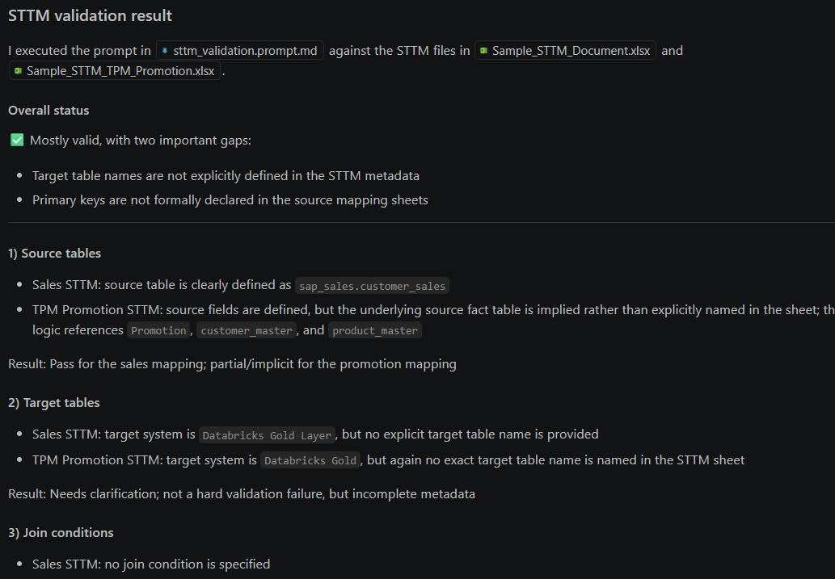

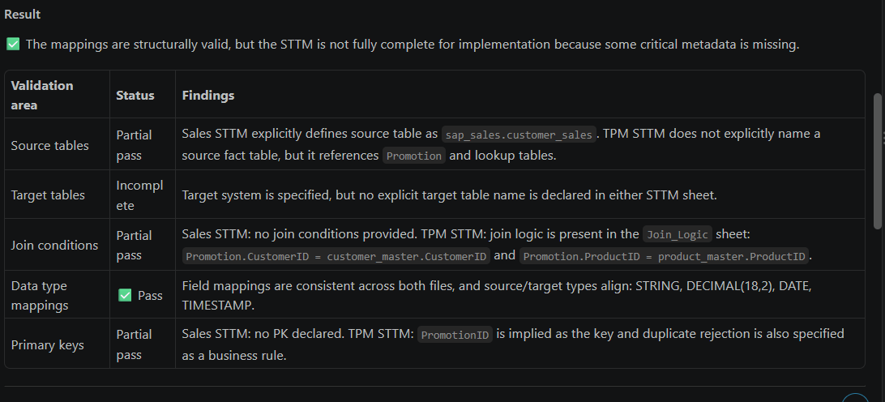

Context management with subagents
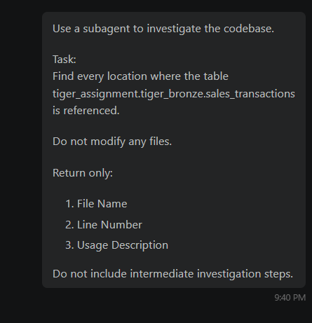

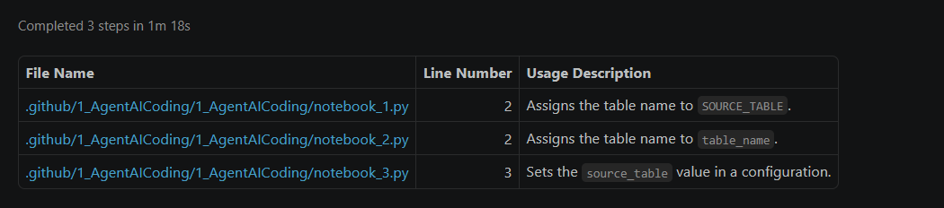

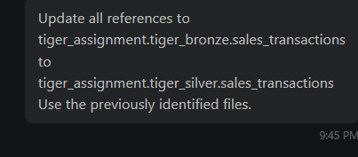

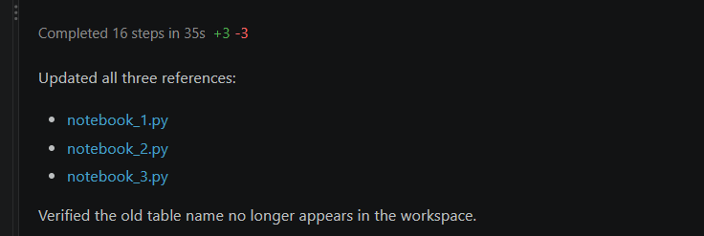

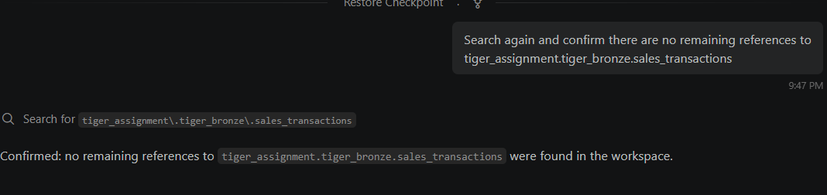

Scenario — Packaging a skill
I have an STTM file.
Can you verify whether it is ready for loading and identify any mapping or master data issues?

Verdict: not ready to load
I found two STTMs in the workspace—Customer Sales and TPM Promotion. I reviewed their worksheets against the corresponding DRDs and release notes. The copies under STTM_Document match the workbooks in the customer and promotion folders.
STTM | Readiness | Main blockers
Customer Sales — STTM_Customer.xlsx | Not ready | Target layer/table disagreement, conflicting revenue rules, and unresolved mapping and key requirements
TPM Promotion — STTM_TPM_Promotion.xlsx | Not ready | Missing source and target table names, conflicting business rules, and an underspecified incremental/master-data load
Customer Sales findings
- Target is unclear: The STTM names “Databricks Gold Layer” but does not specify a target table. The Customer Sales DRD and release notes name bronze.sales, with Gold described as downstream. Confirm the actual load target and record it in the STTM.
- Revenue mapping and rule need confirmation: The STTM maps SalesAmount to Net_Sales, while the release notes refer to NetSales. The STTM excludes SalesAmount <= 0, but the DRD/release notes say revenue must be non-negative. That makes zero-value handling inconsistent.
- Required-field rules are incomplete or inconsistent: The STTM’s business rules explicitly reject null CustomerID, but not null ProductID; the DQ sheet does check both. The release notes also require non-negative SalesQty, which is not present in the STTM rules.
- Key and duplicate handling are unspecified: The release notes call for duplicate-transaction validation, but the STTM does not define a primary key or what makes a transaction a duplicate.
- Market-unit filtering needs operational detail: The STTM limits processing to PBNA_EAST, PBNA_WEST, and PBNA_CENTRAL and uppercases MarketUnit. Specify whether the filter runs before or after normalization and what happens to null or unrecognized values.
- Load operations need definition: The release notes say CDC, delete handling, and incremental loading are not defined. That may be acceptable for a one-time full load, but not for a recurring production load.

TPM Promotion findings
- Source and target tables are not pinned down: The STTM lists source columns and systems, but no source table; the release notes describe the source only generally. The STTM names Databricks Gold as the target system, while the Promotion DRD and release notes name bronze.promotion. Confirm the intended tables and layer.
- Business rules conflict: The STTM requires ExpectedRevenue > 0, but the DRD and release notes allow non-negative revenue. It also requires End Date greater than Start Date, while the release notes allow Start Date equal to End Date. Confirm the intended boundary behavior.
- Incremental strategy is incomplete: LastModifiedTS is identified as the watermark, but the release notes say the incremental strategy is not yet defined. Specify initial-load behavior, watermark boundaries and ties, late-arriving updates, and delete handling.
- Master lookups need deterministic behavior: The STTM names customer and product master joins, but does not specify join type, key uniqueness/cardinality, effective-date handling, or what happens when a lookup has no match. Duplicate master matches could multiply promotion rows.
- Types cannot be fully verified: The STTM declares source and target types, but the provided documents do not establish the actual source/target schemas or master-data key definitions.
Primary-key check: Promotion identifies duplicate PromotionID records as rejected, but should state that Promotion_ID is the target key and how duplicates are handled during incremental updates. Customer Sales has no defined transaction key or duplicate criterion.
These are specification-level findings; I could not verify actual column compatibility, key uniqueness, lookup coverage, or data quality without source/target DDL, master-data definitions, and representative data. Resolve the target/table and rule conflicts first, then validate those items before loading.

I need a quality review of this STTM file.
Please check duplicates and invalid customer mappings.
Quality review: duplicates and customer mappings
I found no duplicate source-to-target mapping rows in either STTM workbook:
- Customer Sales STTM: each listed source column and target column appears once. CustomerID → Customer_ID is a direct mapping.
- TPM Promotion STTM: each listed source and target column appears once. CustomerID → Customer_ID uses a Customer Master lookup.
I can’t confirm whether any customer IDs in the data are invalid. The accompanying JSON files contain extracted document text, not customer or promotion records or a Customer Master dataset. So I could review the mapping definitions, but not test actual IDs for missing master matches or duplicate records.
Customer-mapping concern: The Promotion STTM says to join Promotion.CustomerID to customer_master.CustomerID, but doesn’t specify lookup behavior for unmatched IDs or duplicate master keys. Define how to handle those cases before loading; duplicate master keys could multiply rows. The Customer Sales STTM uses a direct mapping and does not define a customer-master validation.
Duplicate-data checks also remain unverified. The Promotion STTM says to reject duplicate PromotionID records, but no records were provided to test. Customer Sales release notes call for duplicate-transaction validation, while the STTM doesn’t define a transaction key or duplicate criteria.
Bottom line: No mapping-level duplicates found, and neither customer mapping is demonstrably wrong from the specifications alone. Actual duplicate and invalid-customer checks require the source records and the relevant master data.

Enforcing standards automatically
Claude.md
Team Coding Standards
1. Naming Convention
Functions must use snake_case
Variables must use snake_case
Constants must use UPPER_CASE
Avoid abbreviated variable names
Example: customer_revenue sales_amount WAREHOUSE_ID

2. Error Handling Standard
All external operations must use try/except.
Required pattern:
try: # operation except Exception as e: logger.error(f"Operation failed: {e}") raise
Never suppress exceptions using pass.

3. Logging Standard
Use structured logging.
Required format:
logger.info("Starting ") logger.info("Completed ")
Errors:
logger.error("Operation failed")
Do not use print().

Prompt
Create a Python function that reads data from a Unity Catalog table
and returns the row count.
Output
row_count = get_unity_catalog_row_count(spark, "catalog.schema.table")

def get_unity_catalog_row_count(spark_session, table_name: str) -> int:
"""Return the number of rows in a fully qualified Unity Catalog table."""
logger.info("Starting row count for Unity Catalog table %s", table_name)
try:
row_count = spark_session.table(table_name).count()
except Exception:
logger.exception("Operation failed while counting Unity Catalog table %s", table_name)
raise

logger.info(
"Completed row count for Unity Catalog table %s: %d",
table_name,
row_count,
)
return row_count

Generate a utility function that exports a dataframe to csv.
def export_dataframe_to_csv(dataframe: pd.DataFrame, file_path: str) -> None:
"""Export a Pandas DataFrame to a CSV file without its index."""
logger.info("Starting CSV export to %s", file_path)
try:
dataframe.to_csv(file_path, index=False)
except Exception:
logger.exception("Operation failed while exporting CSV to %s", file_path)
raise

logger.info("Completed CSV export to %s", file_path)

The assistant automatically followed repository standards from CLAUDE.md
across two unrelated code-generation tasks without being reminded.
Verified:
✓ Naming convention
✓ Error handling convention
✓ Logging convention

Agentic loop discipline
Created calculator.py notebook
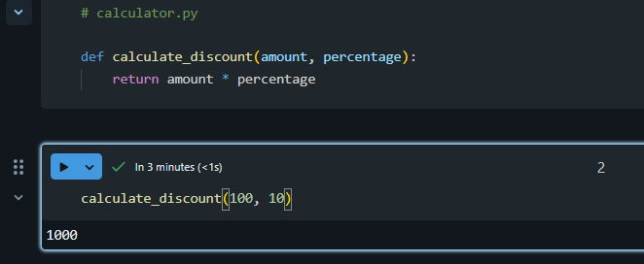

Discount calculation is wrong.
A 10% discount on 100 should return 10 but users are reporting incorrect values.
Follow this process:
- Reproduce the issue using tools.
- Diagnose root cause.
- Propose a fix.
- Apply the fix.
- Verify with a test.
Do not skip verification.
Reject your own solution if verification is not completed.

- Reproduced: calculate_discount(100, 10) returned 1000.
- Root cause: The function multiplied by 10 directly instead of treating it as 10%.
- Fix: Updated calculator.py to divide the percentage by 100.
- Regression test: Added test_calculator.py.
- Verified: The focused unittest passed: calculate_discount(100, 10) == 10.
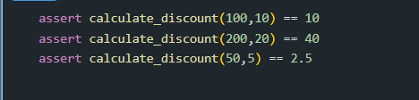
Agentic Loop Discipline
Bug Report Received:
✓ No additional context
Workflow Followed:
✓ Reproduce
✓ Diagnose
✓ Propose Fix
✓ Apply Fix
✓ Verify
Verification Evidence:
✓ Tests executed after fix
✓ Correct output observed
Result:
Scenario completed successfully.

Live data grounding via MCP
Prompt:
What is the schema of table
tiger_assignment.tiger_bronze.sales_transactions
Use the connected Databricks MCP tools to retrieve the schema.
Do not guess
Response:
I can’t retrieve it in this session: no Databricks MCP tools are available to me, so I won’t guess the schema. Could you enable the Databricks connection or share the schema output?

